Towards Accurate Seizure Detection: Machine

Learning Model for Wearable Technology

Dipin Raj   
 *Apex Institute of Technology (CSE)*  
*Chandigarh University*  
*Punjab, India*  
[dipinr505@gmail.com](mailto:dipinr505@gmail.com)   
  
Rashaz Rafeeque   
 *Apex Institute of Technology (CSE)*  
*Chandigarh University*  
*Punjab, India*  
[rashazrafeeque@gmail.com](mailto:rashazrafeeque@gmail.com)Jeevan AJ   
 *Apex Institute of Technology (CSE)*  
*Chandigarh University*  
*Punjab, India*  
[jeevanaj2003@gmail.com](mailto:jeevanaj2003@gmail.com)   
  
Rhishitha T S   
 *Apex Institute of Technology (CSE)*  
*Chandigarh University*  
*Punjab, India*  
[rhishithats002@gmail.com](mailto:rhishithats002@gmail.com)

Akshay S

*Apex Institute of Technology*

*(CSE)*  
 *Chandigarh University*

*Punjab, India*

[akshays23623@gmail.com](mailto:akshays23623@gmail.com)

Merry K P

*Apex Institute of Technology*

*(CSE)*

*Chandigarh University*

*Punjab, India*

[merrypaulose@gmail.com](mailto:merrypaulose@gmail.com)

***Abstract*— Wearable devices that automatically detect and predict seizures could be life-changing technology for patients suffering from epileptic seizures. These devices can help in constant monitoring and detection of seizures. This research aims to produce a Machine Learning (ML)model to detect seizures which can be used in seizure detection wearable devices. With the help of multimodal sensors like Electrodermal Activity (EDA) and Accelerometer (ACC) accurate detection of seizure can be obtained. The system can analyse skin resistance and irregular heartbeats that could indicate an impending seizure. Overall, the research paper aims to demonstrate the potential of a machine learning model which can be used in wearable technology that can enhance seizure management and improve patient outcomes.**

Keywords—Seizure, Electrodermal Activity (EDA), Accelerometer (ACC), Classifiers, Electroencephalogram (EEG).

# Introduction

Epileptic seizure affects approximately 50 million people [1] worldwide. One of the greatest challenges in epileptic seizure is detecting a seizure and responding accordingly to avoid injuries and save lives. Therefore, seizure detection and prediction play a vital role in seizure treatment. But traditional methods such as using an EEG or video EEG to detect seizure are often expensive [1] and not viable for everyday use. Hence developing a wearable device using machine learning model could be a paradigm-shifting technology in the field of epilepsy.

This research paper seeks to address the accurate detection of an onset seizure using a machine learning model. The model must be trained using sensor data obtained from wearable devices. The system should be capable of collecting and storing physiological signals like EDA and ACC, which can help identify the occurrence of seizures. The model should be trained on a large dataset of labelled seizure and non-seizure data to enable it to learn the complex patterns and characteristics associated with seizures. The system should be designed to be highly sensitive and specific, to minimize false alarms and missed detections. The article concludes by presenting outlooks on wearable multi-functional sensing technology and its potential for use in precision medicine. The following Fig.1 is a graphical representation of seizure detection and treatment loop comprise sensors to monitor brain activity, a detection algorithm to identify seizures, and an alert system to notify caregivers or healthcare professionals.

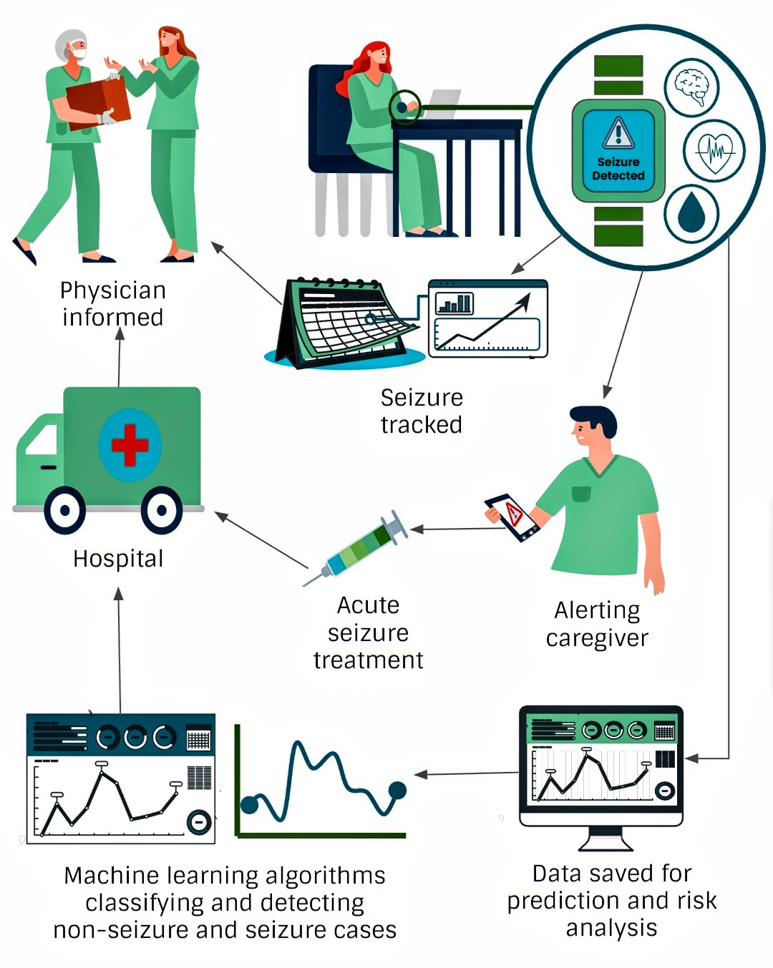

Fig 1: The Seizure Detection and Intervention Cycle

# Literature Survey

*2.1. SEIZURE AND ITS CLASSIFICATIONS:*

Seizure and its classifications are the main topics of the study article. Sensors are employed to identify physical or chemical attributes associated with epileptic episodes. Machine learning classifiers are used to classify and localize data. According to the International League Against Epilepsy's (ILAE) new language, this idea relates to the division of epileptic episodes [2] into several categories. The four different forms of seizures—focal, generalized, combination generalized and focal, and unknown seizures [3] are the main topics of the study work.

*2.2. SENSORS:*

Detection and measurement tools for physical or chemical attributes are referred to by this idea. Sensors are employed in the study article [4][5] to identify the physical changes and motions linked to epileptic episodes. Seizure detection is done through the application of technology [6] such as sensors and machine learning algorithms. Lastly, ELECTRODERMAL ACTIVITY (EDA) is the evaluation of variations in skin's electrical conductivity.

*2.3. MACHINE LEARNING CLASSIFIERS:*

The algorithms used to classify, or categories data based on input features fall under this idea. The study article [7][8] examines the application of several machine learning classifiers, such as decision forests and black-box classifiers [9], for seizure detection and localization. Seizure detection is assessed during epileptic seizures and wearable devices with embedded biosensors and ML algorithms are used to monitor and track them.

*2.4. SEIZURE DETECTION:*

This idea deals with the detection of epileptic seizures by the application of technology, such as sensors and machine learning algorithms. The study [10] utilized ML algorithms and biosensors that were embedded in the wearable devices. The sensor recorded ACC, PCG, and EDA. The study article [11][12] examines several seizure detection strategies, including the application of biosensors and wearable technology. The lives of people with epilepsy and those who care for them might be improved [13][14] by the use of technology in seizure detection. Biosensors and wearable technologies may become crucial tools in the treatment of epilepsy and other neurological illnesses [15] with further study and development.

*2.5. ELECTRODERMAL ACTIVITY (EDA):*

This term refers to the evaluation of variations in skin's electrical conductivity, which can serve as a proxy for both mental and physical states. EDA is assessed during epileptic seizures in the context of the study article [16] to better understand their physiological impacts. The experiment [17][18] was successful in showing an increasing EDA response during ictal and postictal periods of seizure. It was observed that focal seizures had lower EDA response compared to others. Although EDA sensors have been promised as a seizure detection tool, there are still a number of issues that need to be resolved. For instance, perspiration, movement, and other things that might influence skin conductance can have an impact on EDA sensors.

*2.6. WEARABLE HEALTH CARE DEVICES USING AI:*

This idea relates to the monitoring and tracking of epilepsy sufferers using wearable gadgets using Artificial Intelligence (AI) technology. In the study article [19], seizure detection and categorization using wearable devices with embedded biosensors and ML algorithms is discussed. AI technology is used to make prognosis forecasts [20] [21] and determine the best course of therapy for each patient. Finally, technology is being used to notify family members and medical professionals [22] when a seizure has occurred.

*2.7. AI-BASED TREATMENT PLANS FOR SEIZURES:*

The study article [23] discusses the use of technology for seizure detection and categorization, AI-based treatment plans for seizures, and algorithms. This idea [24] relates to the use of AI technology to the automated diagnosis and prognosis forecasting of specific epilepsy patients. In order to determine the best course of therapy for each patient, the study article explores the use of computer studies that apply AI and ML approaches.

*2.8. ALERTING THE CARERS IN THE NEED OF TIME:*

This idea relates to the use of technology to notify family members and medical professionals [25] when an epilepsy patient has a seizure. The study article [26] covers the use of fall detection algorithms and motion sensors to develop an alert system that sends an SOS alarm, call, SMS, and GPS location to family members and medical professionals to obtain assistance more quickly.

# Proposed System

The suggested solution uses a machine learning model that can precisely identify seizures in epileptic patients. The system uses wearable sensors to gather information on physiological variables such as skin resistance, mobility, heart rate, and others. The system's major objective is to create a machine learning model that is extremely sensitive and focused and is capable of reliably detecting seizures in real time. To enable it to learn the intricate patterns and traits connected to seizures, the model should be trained on a sizable dataset of labelled seizure and non-seizure data. The study's main objective is to reduce the false alarm rate (FAR), which will raise the model's accuracy.

The creation of a wearable device-based seizure detection system is fraught with several technological difficulties. These consist of:

* It can be difficult to acquire high-quality data from sensors in a real-world setting because the sensors must be at ease and inconspicuous while accurately gathering crucial data.
* The data must then be analysed in order to draw out relevant elements that can be utilised to pinpoint when a seizure is occurring. It may be required to use sophisticated signal processing and machine learning techniques because of how intricate this process is.
* The classification of whether a seizure is happening requires the usage of the extracted features. This is often accomplished using machine learning methods, however due to the variety in seizure patterns, creating precise and trustworthy classifiers can be difficult.
* The technology must also be able to function in real-time, sending notifications as soon as a seizure starts. Data processing algorithms that are effective and optimized for speed and accuracy are needed for this.

# Methodology

In order to work with the dataset, the required libraries, including Pandas, NumPy, Matplotlib, and Seaborn, were loaded. To continue working, the CSV file was read and placed in a variable. The raw dataset is subsequently divided into a 25,000-row subset. Accelerometery ACC (x, y, z, and magnitude), electrodermal activity (EDA), heart rate variability (HR), and blood volume pressure (BVP) are the characteristics in the multimodal data. The data was first cleansed, with null or incorrect values replaced and corrected. The ACC values showed strong correlations. We were able to identify a variation and trend in the data points by graphing the EDA and HR values. As a result, the threshold values were calculated, and the rows where the thresholds were lower than the actual data value were classed as 1 and the remaining rows as 0, respectively. After that, the data were separated into training and testing sets. Then, to use the dataset, the machine learning algorithms were imported and put into use. The machine learning algorithms' ROC curves and performance measures were obtained.

Classification algorithms used: The machine learning algorithms that were used to work with the dataset are Logistic Regression, Random Forest Classifier, Gradient Boosting Classifier, SVM (Support Vector Machine), KNN (K-Nearest Neighbors), GNB (Gaussian Naive Bayes), MLP (Multi-Layer Perceptron) were imported and used.

* Logistic Regression: Using the set of independent variables, logistic regression can be used to predict the outcome of the categorical dependent variable and output a discrete value that is a probabilistic value between 0 and 1. The logistic regression curve we find provides the likelihood of anything. The incidence of seizures in this instance.
* Random Forest Classifier: The creation of the random forest by mixing the N decision trees occurs in the first of two phases, after which predictions are made for each of the trees. Decision trees are constructed using the K data points that are chosen from the training set.
* Gradient Boosting Classifier: Gradient boosting classifier makes use of the process of boosting to combine the predictors with poor accuracy into a model with strong accuracy. Each of the predictor here tries to improve on its predecessor by attempting to reduce the errors.
* SVM: SVM or Support Vector Machine helps in creating a hyperplane that can be used to segregate n dimensional space into classes. This helps us to classify the new and incoming datasets into the correct category. The extreme vectors which are used to create a hyperplane are known as support vectors.
* K-Nearest-Neighbor: KNN algorithm works by assuming the similarity between new data and available data. According to the similarity it assigns the new data to the most similar one. It selects the K number of neighbours first and foremost and calculates the Euclidean distance between them. Then it counts the number of data points and assigns them where the number of neighbours is maximum.
* Gaussian Naïve Bayes: The Naive Bayes method, which uses the Bayes theorem as its foundation, is used to forecast an object's likelihood. The Bayes Theorem is used to calculate the likelihood of a hypothesis given previous information. The probabilities of the provided characteristics are used to construct likelihood tables and transform the dataset into frequency tables. The posterior probability is then calculated using the Bayes Theorem.
* Multi-Layer Perceptron: It is a library provided by TensorFlow Python. Any input dimension can be changed into the desired dimension using it. It is a neural network with several layers.

# Result

This study aimed to assess the performance of various machine learning algorithms in detecting seizures by leveraging multimodal data obtained from wearable devices. The algorithms evaluated included Logistic Regression, Support Vector Machine, K-Nearest Neighbors, Naive Bayes, and Multilayer Perceptron. Evaluation metrics such as accuracy, precision, recall, and F-score were used to compare their efficacy. The data used in this research was raw and unlabeled, comprising approximately 32 lakh data points collected from one patient for a period of 6 hours. The data was then partitioned into smaller segments containing 25,000 data points and subsequently divided into two modules for training and testing purposes.

In the study of the multimodal datasets, among all the classifiers tested it is evident that the MLP classifier transcended in performance, as evidenced by its accuracy of 97.4%, precision of 94.8%, recall of 96.8%, and F-score of 95.6%. The Logistic Regression approach has good accuracy, precision, recall, and F-score, measuring 97.2%, 94.8%, 95.9%, and 95.3%, respectively. The Support Vector Machine Algorithm's F-score was 95.2% because it had the best accuracy (97.2%), Recall of 95.6%, but a lesser precision (94.7%). The K-Nearest Neighbours and Naive Bayes methods performed the worst overall, with accuracy ratings of 96.3% and 96.6%, respectively. The MLP classifier excels in handling multimodal datasets, as evidenced by its superior performance in ROC curves (Fig.2, Fig.3) and on the multimodal dataset (Table 1, Fig.4). Its ability to capture non-linear interactions between the target variable and features contributes to its strong classification performance.

Table 1: Performance on Multimodal Dataset

|  |  |  |  |  |
| --- | --- | --- | --- | --- |
| **Machine Learning Algorithms** | **Accuracy** | **Precision** | **Recall** | **F_Score** |
| Logistic Regression | 97.2% | 94.8% | 95.9% | 95.3% |
| Support Vector Machine | 97.2% | 94.7% | 95.6% | 95.2% |
| K-Nearest Neighbors | 96.3% | 94.6% | 92.3% | 93.4% |
| Naive Bayes | 96.6% | 92% | 97.9% | 94.6% |
| Multilayer Perceptron | 97.4% | 94.8% | 96.5% | 95.6% |

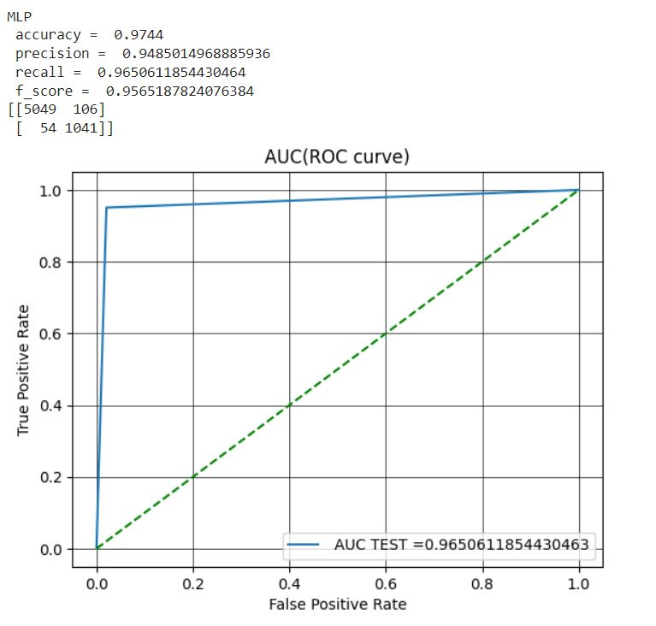

Fig 2: ROC curve of Multilayer Perceptron

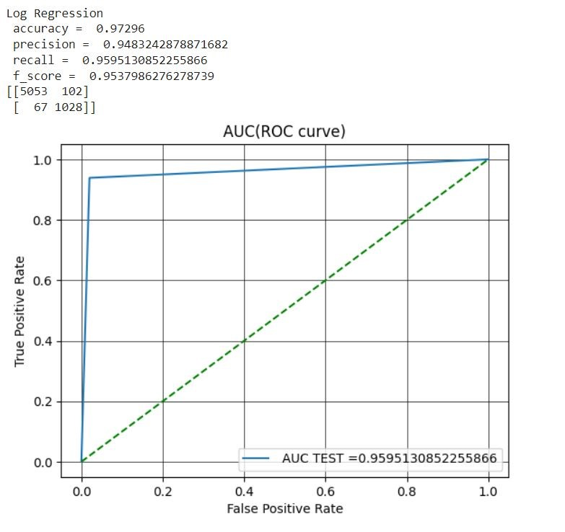  
Fig 3: ROC curve of Logistic Regression

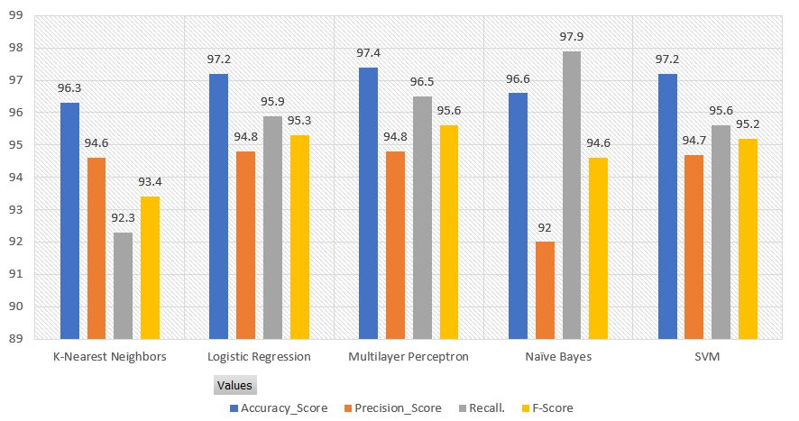

Fig 4: Performance Metrics

# Conclusion

The research on the use of multimodal datasets and machine learning algorithms to detect seizures has shed light on the potential of wearable technology and biosensors for reliably detecting seizures. In terms of accuracy, precision, recall, and F-score, the findings show that the Multilayer Perceptron (MLP) classifier performed better than other classifiers. The results demonstrate how machine learning algorithms are successful at managing multimodal datasets and their capacity to detect non-linear interactions between the target variable (seizure incidence) and the attributes acquired from wearable device data. A good option for seizure detection systems using wearable technology is the MLP classifier, which in particular shows its capacity to handle complicated patterns and interactions within the data.

These findings imply that seizure detection using wearable device data can be successfully accomplished by machine learning algorithms. The Multilayer Perceptron and Logistic Regression algorithms demonstrated the greatest results and would be appropriate for wearable seizure detection systems. Wearable seizure detection devices can help patients receive better care, contribute to more individualized and targeted treatment plans, and improve the quality of life for people with epilepsy with further development and integration with healthcare systems. More investigation is required to assess how well these algorithms perform on larger and more varied datasets, as well as to examine the viability and usability of real-time seizure detection systems using wearable technology in clinical settings.

# Reference

1. Beghi, E., 2020. The epidemiology of epilepsy. *Neuroepidemiology*, *54*(2), pp.185-191.
2. Sarmast, S.T., Abdullahi, A.M. and Jahan, N., 2020. Current classification of seizures and epilepsies:scope, limitations and recommendations for future action. Cureus, 12(9).
3. Falco-Walter, J.J., Scheffer, I.E. and Fisher, R.S., 2018. The new definition and classification of seizures and epilepsy. Epilepsy research, 139, pp.73-79.
4. Humairah Tabasum, Nikita Gill, Rahul Mishra and Saifullah Lone. Wearable microfluidic-based e-skin sweat sensors.
5. Xu Zeng, Hai-Tao Deng, Dan-Liang Wen, Yao-Yao Li, Li Xu and Xiao-Sheng Zhang. Wearable Multi-Functional Sensing Technology for Healthcare Smart Detection.
6. Chen, F., Chen, I., Zafar, M., Sinha, S.R. and Hu, X., 2022. Seizures detection using multimodal signals: a scoping review. Physiological Measurement.
7. Alazzam, M.B., Alassery, F. and Almulihi, A., 2021. A novel smart healthcare monitoring system using machine learning and the Internet of Things. Wireless Communications and Mobile Computing, 2021, pp.1-7.
8. Rosales, M.A., Bandala, A.A., Vicerra, R.R. and Dadios, E.P., 2019, November. Physiological-Based Smart Stress Detector using Machine Learning Algorithms. In 2019 IEEE 11th International Conference on Humanoid, Nanotechnology, Information Technology, Communication and Control, Environment, and Management (HNICEM) (pp. 1-6). IEEE.
9. Siddiqui, M.K., Morales-Menendez, R., Huang, X. and Hussain, N., 2020. A review of epileptic seizure detection using machine learning classifiers. *Brain informatics*, *7*(1), pp.1-18.
10. Jonas Munch Nielsen, Ivan C. Zibrandtsen, Paolo Masulli, Torben Lykke Sørensen, Tobias S. Andersen, Troels Wesenberg Kjær. Towards a wearable multi-modal seizure detection system in epilepsy.
11. Sai Manohar Beeraka, Abhash Kumar, Mustafa Sameer, Sanchita Ghosh, Bharat Gupta. Accuracy Enhancement of Epileptic Seizure Detection: A Deep Learning Approach with Hardware Realization of STFT.
12. Tang, J., El Atrache, R., Yu, S., Asif, U., Jackson, M., Roy, S., Mirmomeni, M., Cantley, S., Sheehan, T., Schubach, S. and Ufongene, C., 2021. Seizure detection using wearable sensors and machine learning: Setting a benchmark. Epilepsia, 62(8), pp.1807-1819
13. Beniczky, S., Wiebe, S., Jeppesen, J., Tatum, W.O., Brazdil, M., Wang, Y., Herman, S.T. and Ryvlin, P., 2021. Automated seizure detection using wearable devices: A clinical practice guideline of the International League Against Epilepsy and the International Federation of Clinical Neurophysiology. Clinical Neurophysiology, 132(5), pp.1173-1184.
14. Regalia, G., Onorati, F., Lai, M., Caborni, C. and Picard, R.W., 2019. Multimodal wrist-worn devices for seizure detection and advancing research: focus on the Empatica wristbands. Epilepsy research, 153, pp.79-82.
15. Lockman J, Fisher RS, Olson DM. Detection of seizure-like movements using a wrist accelerometer. Epilepsy Behav. 2011 Apr;20(4):63841. doi: 10.1016/j.yebeh.2011.01.019. Epub 2011 Mar 29.
16. Ortega, M.C., Bruno, E. and Richardson, M.P., 2022. Electrodermal activity response during seizures:A systematic review and meta-analysis. Epilepsy & Behavior, 134, p.108864.
17. Posada-Quintero, H.F. and Chon, K.H., 2020. Innovations in electrodermal activity data collection and signal processing: A systematic review. Sensors, 20(2), p.479.
18. Zangróniz, R., Martínez-Rodrigo, A., Pastor, J.M., López, M.T. and Fernández-Caballero, A., 2017. Electrodermal activity sensor for classification of calm/distress condition. Sensors, 17(10), p.2324.
19. Bornoiu, I.V. and Grigore, O., 2013, May. A study about feature extraction for stress detection. In *2013 8th International Symposium on Advanced Topics in Electrical Engineering (ATEE)* (pp. 1-4). IEEE.
20. Majumder, A.K.M., ElSaadany, Y.A., Young, R. and Ucci, D.R., 2019. An energy efficient wearable smart IoT system to predict cardiac arrest. Advances in Human-Computer Interaction, 2019.
21. Van Andel, J., Ungureanu, C., Aarts, R., Leijten, F. and Arends, J., 2015. Using photoplethysmography in heart rate monitoring of patients with epilepsy. Epilepsy & Behavior, 45, pp.142-145.
22. Nasseri, M., Pal Attia, T., Joseph, B., Gregg, N.M., Nurse, E.S., Viana, P.F., Worrell, G., Dümpelmann, M., Richardson, M.P., Freestone, D.R. and Brinkmann, B.H., 2021. Ambulatory seizure forecasting with a wrist-worn device using long-short term memory deep learning. *Scientific reports*, *11*(1), p.21935.
23. Mustafa Halimeh, Yonghua Yang, Theodore Sheehan, Solveig Viieluf, Michele Jackson, Tobias Loddenkemper, Christian Meisel. Wearable device assessments of antiseizure medication effects on diurnal patterns of electrodermal activity, heart rate, and heart rate variability.
24. An, S., Kang, C. and Lee, H.W., 2020. Artificial intelligence and computational approaches for epilepsy. Journal of epilepsy research, 10(1), p.8.
25. Adwitiya, A.Y., Hareva, D.H. and Lazarusli, I.A., 2017, September. Epileptic Alert System on Smartphone. In 2017 International Conference on Soft Computing, Intelligent System and Information Technology (ICSIIT) (pp. 288-291). IEEE.
26. Moodbidri, A. and Shahnasser, H., 2017, January. Child safety wearable device. In 2017 International Conference on Information Networking (ICOIN) (pp. 438-444). IEEE.